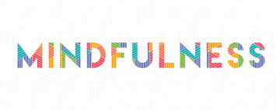
The awareness that arises
from paying attention
in a particular way to the present moment,
on purpose and without judgment.

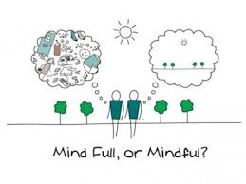

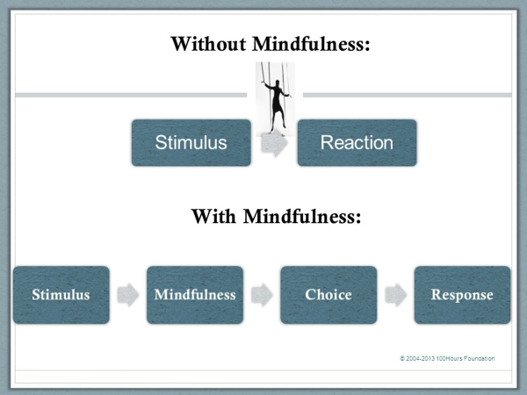

resistance
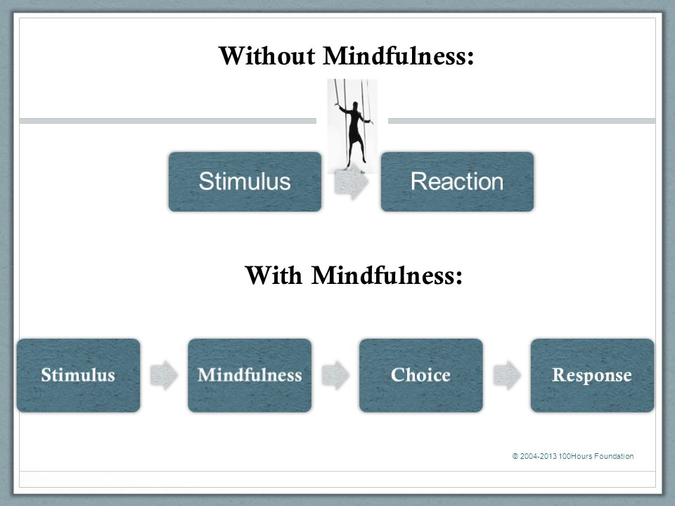
Striving
WISDOM
CLARITY OF MIND
MULTIPLE PERSPECTIVES
THOUGHTFULLY
SENSITIVITY
CONTENTMENT AND EASE

Ruminating/Obsessing
COMPASSION
GRATITUDE
Resisting
Self-Doubt
Catastrophizing
Craving
Worrying
THOUGHTFULNESS
FORGIVENESS
ACCEPTANCEEE
OPENNESS
KINDNESS
LETTING GO
CURIOSITY
FRESH EYES

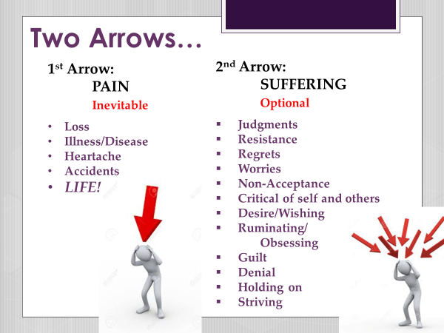

Fight Flight Freeze

- Adaptive for primitive species

- Protective response to prepare the body for imminent danger

- Key to survival

- Activated by the Sympathetic Nervous System

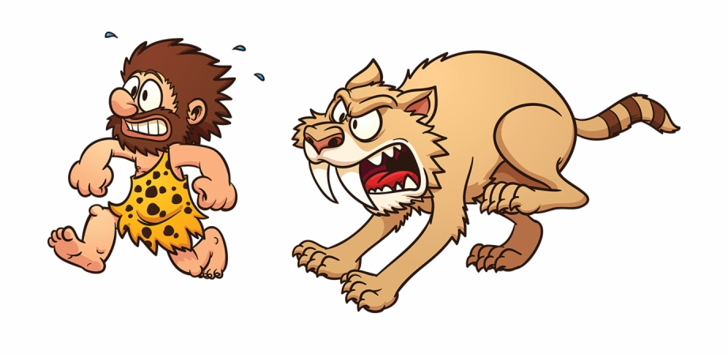

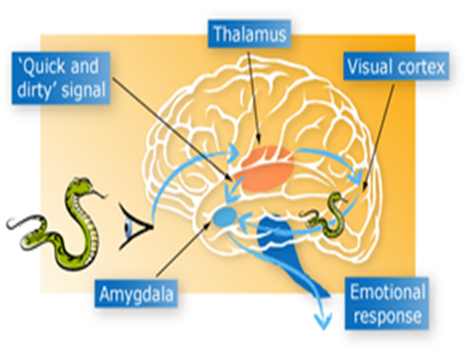

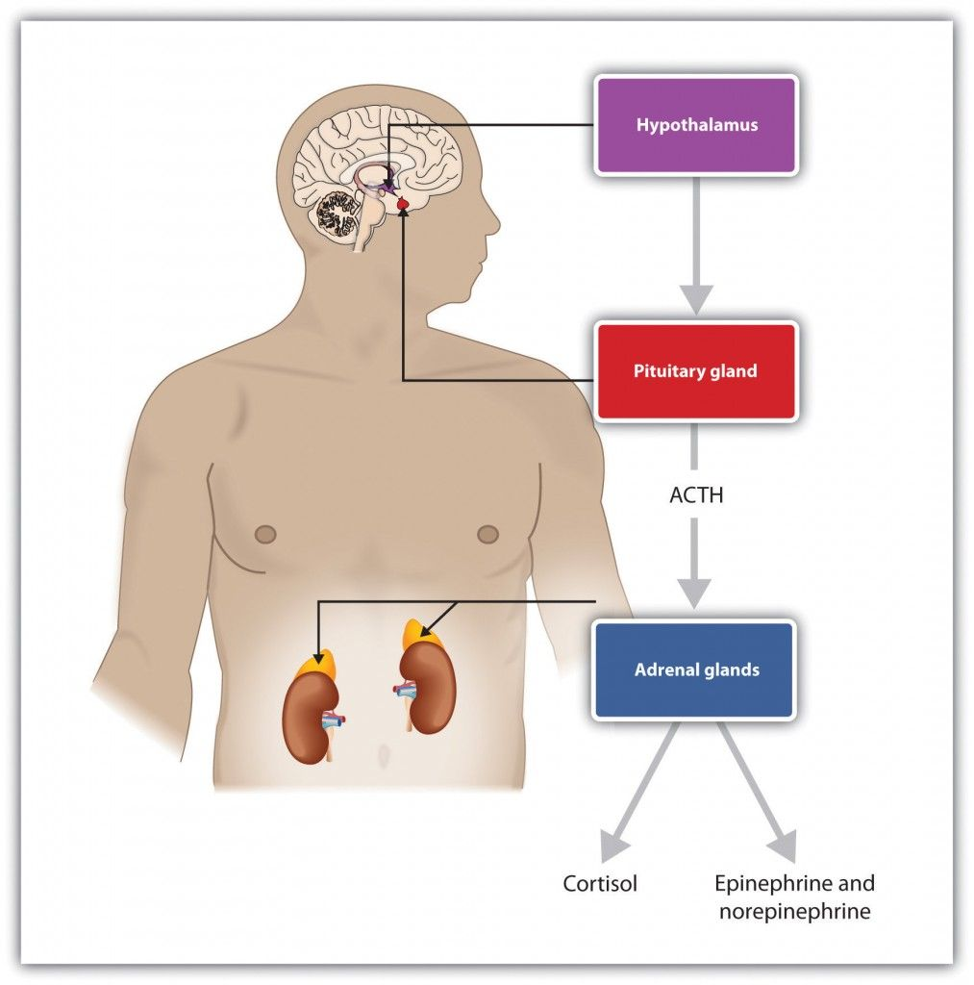

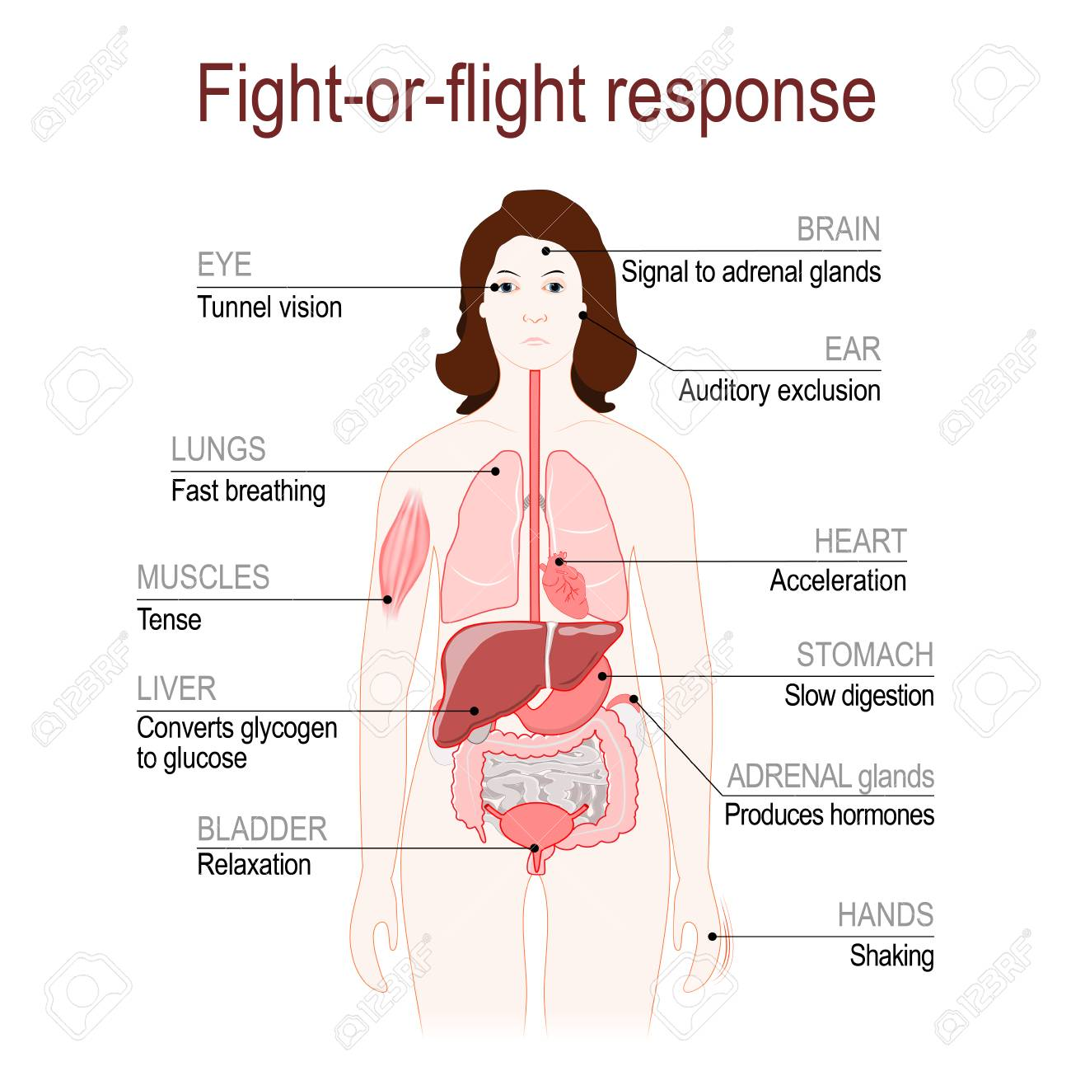

False Alarm
Fight Flight is Triggered by Perceived Threats

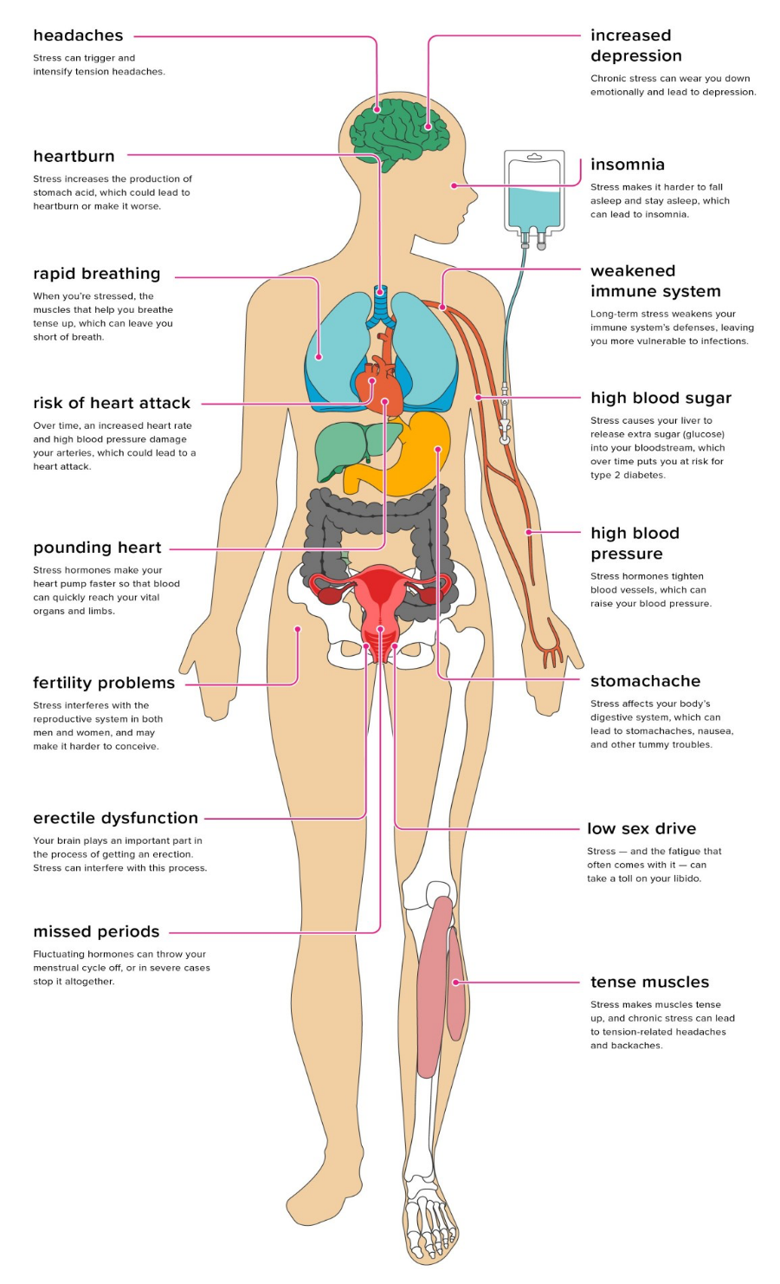

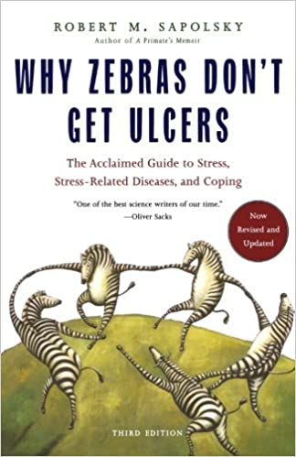
FIGHT FLIGHT FREEZE
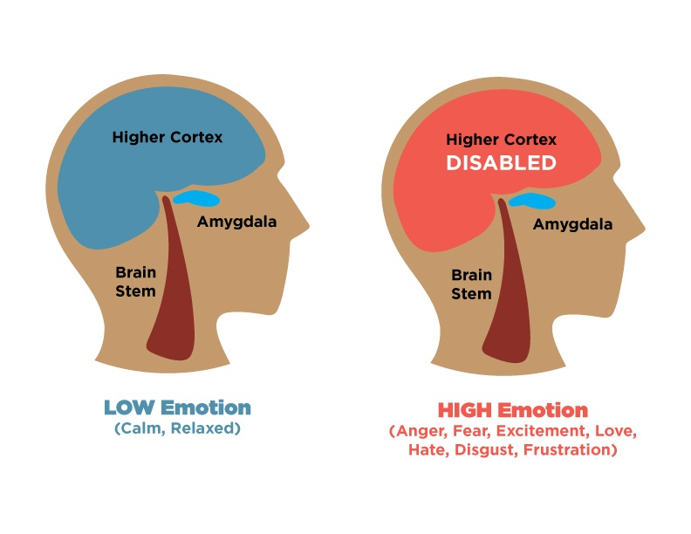

SR
A Stimulus leading to an Immediate Reaction

- Automatic
- Immediate - Fast
Stuck
Blocked
Helpless
Doors Closed
No Solution
No Way Out
- Autopilot
- Fight Flight Freeze
- Habitual Pattern of Reactivity

Habit Formation
Unhealthy Behaviors
Maladaptive Coping

S R
A

When Awareness is introduced it allows us SPACE, a PAUSE and the freedom to CHOOSE our response!
Leading to more skillful actions in alignment
with our intentions and valu

Respond Wisely
A A A
Respond Creatively
S choice R Respond Thoughtfully

A A A Respond Deliberately

Kindness Compassion Empathy Forgiveness Gentleness
Thoughtfulness Gratitude Appreciation Openness Acceptance
Letting Go Wisdom Love Fresh Eyes Beginners Mind
Non-Striving Being vs. Doing
Curiosity Heartfulness

Mindful Mediated Response

Brain Evaluation/Appraisal

Trigger/Event

Unpleasant
Pleasant

I Want
Habit Formation
Unhealthy Behaviors
Maladaptive Coping

I Don’t Want

I Need

Change Course

Brain Evaluation/Appraisal

Trigger/Event

A
Unpleasant
Pleasant

Habit Formation
I Want

I Don’t Want

I Need
Change Course
Change Course
Past – Now – Future (PNF)

- Where are my thoughts?
In the past, in the future or in the “here and now”

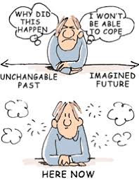

- If I am ruminating or obsessing in the past or future, ask yourself:
“Is this helping me in any way right now?”

- If the answer is “NO” – Let it go! Come back to what is here and now

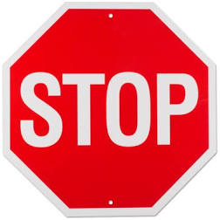

S. STOP

T. Take 2-3 Breaths

O. Observe
- Thoughts
- Emotions
- Red Flags – Bodily Sensations
- Recognize “Body-Mind Connection”

THEN… focus on the present moment

- Sensations of the Breath and/or Your 5 Senses

P. Proceed Thoughtfully

Zones of Tolerance
LEARNING ZONE
OVERWHELLMED
ZONE!!
CCOMFORT
ZONE

Zoned Out OUT

Neuroplasticity
the brain's ability to create new neural pathways based on repetitive behavior
Accepting
Open
Curious
Patient
Kind
Compassionate
Forgiving
Appreciative
Grateful
Positivity
Gentleness
Stop/Pause
Thoughtful
Selfless
Giving
Present
Deliberate
Content
Letting Go

Reactive
Impulsive
Judgmental
Critical
False Narratives
Negativity
Catastrophizing
Ruminating
Resisting
Closed off
Autopilot
Unaware
Driven by emotions
Automatic
Wanting
Needing
Holding On

Positive Neuroplasticity
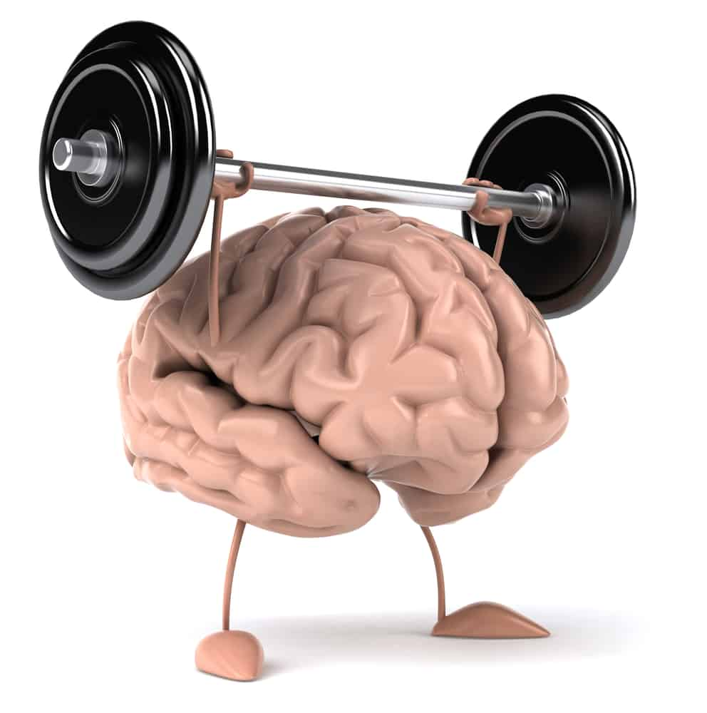
Negative Neuroplasticity

