Wendy Weckstein, PT, MEd Northern Michigan Psychiatric Services, PC
www.mindfulnesstc.com
wendyweckstein@gmail.com
(C) 231-342-9634 (O) 231-935-0355

Welcome to this MBSR Orientation!

What is Mindfulness Based Stress Reduction - MBSR?
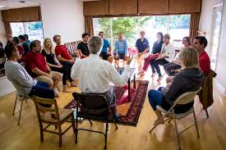
MBSR is an eight-week, evidence-based program offering secular, intensive mindfulness training; assisting people with a host of stress-related physical, emotional and psychological conditions.
MBSR is group-based and highly experiential, using a combination of mindfulness meditation, body awareness practices, yoga, and self-reflection; exploring our habitual patterns of behavior, thinking, feeling and action.
MBSR is not a therapy. Instead, it is psychoeducational in nature and offers a practical approach for gaining deeper insight and awareness into our lives, as well as how we tend to relate to the experiences of our lives.
MBSR systematically cultivates and strengthens one’s ability to actively attend to whatever it is that is happening right now - in the present moment; instead of missing so many of these precious moments entangled in ruminating thoughts and strong emotions related to the past or future. With enhanced present moment awareness, we have the ability to see more clearly what is actually here to be known - and to notice when perhaps, we are being driven by strong emotions and reactivity.
Through structured weekly classes and regular at-home practice, MBSR is designed to help us uncover our innate capabilities and inner resources for managing stress and regulating emotions, and for being with all the experiences of our lives with a greater level of stability, clarity, sensitivity and ease. As we learn to use these tools, we find we have the ability to more skillfully navigate through life’s inevitable challenges and to live our lives more centered, and with more contentment and joy.
Integrating mindfulness into our lives offers us the potential to deeply transform our relationship towards ourself, others, our experiences and the world around us. However, It is important to realize that MBSR is not a panacea.
Although mindfulness is a powerful tool with the potential to provide us with many benefits, it is a compliment, not a replacement to modern medicine. There are no guarantees or predications as to a particular outcome – each person responds differently – however in general those who practice regularly and consistently, report more positive outcomes!

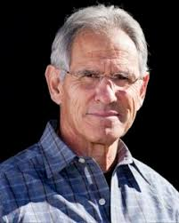
MBSR was founded in 1979 by Dr. Jon Kabat-Zinn at the University of Massachusetts Medical Center.
MBSR is deeply rooted in the spiritual teachings of Bushism from over 2500 years ago. This course was designed to utilize the universal principles of mindfulness in offering a secular, or non-spiritual, approach for managing physical and emotional pain and suffering resulting from stress-related disease processes.
His goal was to create a program for intensive mindfulness training that could be accessible to everyone – reaching far beyond just those interested in Far Eastern spiritual practices.

Research

- University of Massachusetts www.umassmed.edu/mbsr-journalarticles -
- Brown University www.brown.edu/public-health/mindfulness/research -
- University of Wisconsin – Richard Davidson www.centerforhealthyminds.org/about/founder-richard-davidson -
- Mindful Awareness Research Center – UCLA https://www.semel.ucla.edu/marc

Science

- Positive Neuroplasticity – the ability of the brain to change and grow - building new and stronger neuronal pathways based on repetitive behavior. (both positive and negative)

- Brain Growth – functional imaging reveals increase brain growth in regions of the brain associated with empathy, compassion, perspective taking, emotional regulation - mood, memory, planning and attention…to name a few - and a down- regulation and size of the ‘alarm center’ (amygdala)

Potential Benefits MBSR

- Improved emotional regulation
- Enhanced ability to cope with - and ameliorate the secondary complications and effects of chronic illness and stress
- Enhanced resiliency
- Improved sense of well-being
- Improved self-esteem
- Increased ability to meet high stress situations with calmness and clarity of mind
- Improved self-care: better able to care for oneself in the midst of high stress demands
- Improved attention
- Improved Impulse control
- Decreased reactivity
- Increased ability for broader perspective taking; empathy, compassion and kindness towards self and others
- Reduction of self-harming behaviors
- Improved sense of self-efficacy and self-control
- Prevents, reverses and/or reduces symptoms of numerous disease processes:

  - Anxiety
  - Depression
  - PTSD
  - Chronic Pain
  - Fibromyalgia
  - Skin Disorders
  - Sleep Disorders

  - Hypertension
  - Heart Disease
  - Asthma
  - Cancers
  - Addictions
  - Eating Disorders

What is Mindfulness?
“The awareness that arises from paying attention in a particular way to the present moment, on purpose and without judgment.” JKZ
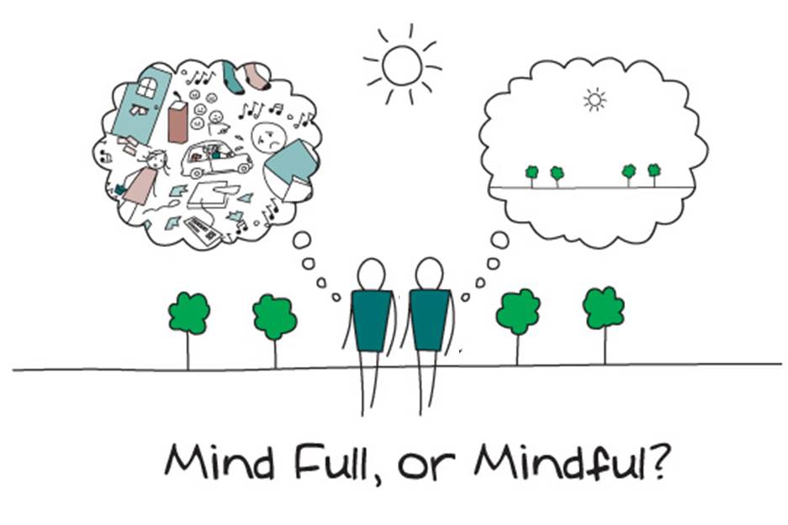

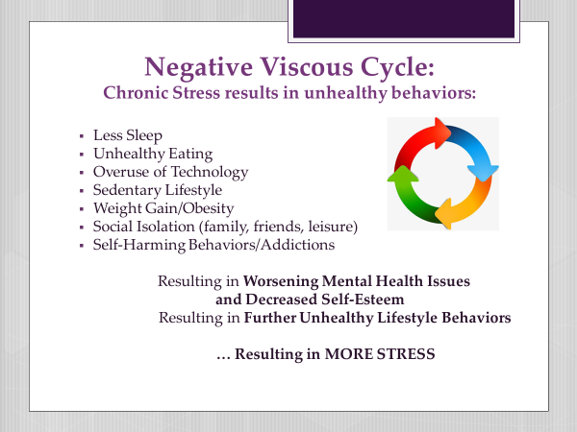

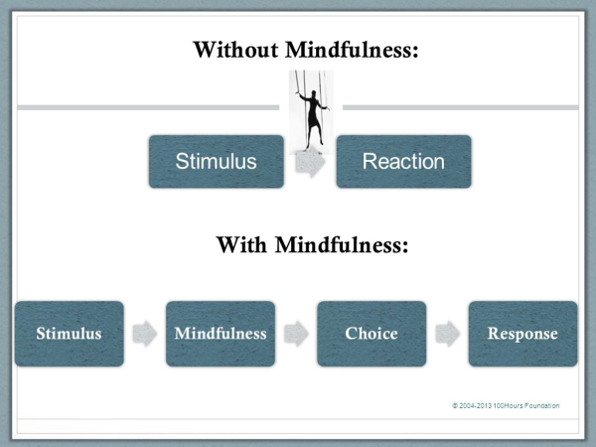

Victor Frankl Quote

“Between stimulus and response there is a space.

In that space is our power to choose our response.

In our response lies our growth and our freedom.”

Potential Risks
Engagement in an MBSR Program may be seen as a risk to one’s lifestyle given time and commitment. It may exacerbate or bring into one’s awareness – more strongly- physical, emotional, psychological or relational issues

- Physical
- Emotional
- Psychological
- Social
- Time

MBSR Class Guidelines

Confidentiality
- Whatever is shared is to be held by the group alone.
- Refraining from commenting to someone about what they shared in class – outside of class time.

Self-care
- Wear comfortable loose waisted clothing.
- Wear layers in order to adjust to temperature changes in your designated classroom space.
- Have a water bottle with you during class.
- Bring whatever props or items that you would like for necessary support and/or comfort
- *Take care to listen to your body and its needs – (changing positions, opting out of a practice that is too emotionally or physically challenging in any way, using the rest room….whatever may be needed!)
- *Encouraged to contact me for support or guidance: 231-342-9634

Attendance
- It is important to attend every class in order to achieve optimal benefit.
- Each week builds on the prior week’s practices and themes.
- Please call or notify Wendy if you will be missing a class for any reason.
- You will have access to a Zoom recording for your review should you need to miss a class
- If you will need to miss more than 2 classes it may be best to attend another session when you will be more available.

Other Classroom Guidelines
- Do your best to keep your shared remarks related to you, and your personally experienced – instead of commenting about or offering advice regarding other participants experiences
- Be mindful of time as you speak

Home Practice
- Home practice is an integral part of the program.
- This may take approximately 45 minutes to 1 hour each day.
- This commitment to make time each day for practice will involve preparation logistically, socially and materially.
- The willingness to meet oneself in the face of resistance, fatigue, boredom, restlessness, fear, pain, or whatever may arise - is extremely important!
- *You will be provided with a recording and a home assignment sheet each week.
Recordings:
All recordings for weekly practices can be found at, www.mindfulnesstc.com under “Free Adult Meditations.”

Class Documents
Weekly Home Practices can be found at www.mindfulnesstc.com on the MBSR class page within “Class Documents.”

Optional - but Recommended Daily Self-Care

- 60 minutes of Daily Physical Activity (30-45 minutes 3-7 days/week should be aerobic in nature)

- Get outside and enjoy nature

- Get enough sleep

- Be thoughtful of time spent on technology

- Eat a healthy diet

- Keep a Journal throughout this experience - What you are noticing as a result of your regular mindful practice/home assignments

How to Support Getting the Most Out of This Course

- Strong commitment to daily practice

- Actively cultivating a stance of curiosity, openness and a beginner’s mind, a fresh mind

- Realizing that there is no right or wrong way to do this or to experience this practice

- Attend all 8 weeks and full day retreat

- Fully engaging in class even if you do not wish to share

- Recognizing that while practice seems simple, bringing moment to moment awareness to our experiences formally and informally,

“is the hardest thing in the world to do” JKZ

MBSR Class Schedule

Week 1
Saturday, March 27th
9:00-11:30 am EST

Week 2
Saturday, April 3rd
9:00-11:30 am EST

Week 3
Saturday, April 10th
9:00-11:30 am EST

Week 4
Saturday, April 17th
9:00-11:30 am EST

Week 5
Saturday, April 24th
9:00-11:30 am EST

Week 6
Saturday, May 1st
9:00-11:30 am EST

Full Day Silent Retreat
Saturday, May 8th
8:45am-4:30pm EST

Week 7
Saturday, May 15th
9:00-11:30 EST

Week 8
Saturday, May 22nd
9:00-11:30 EST

- Arrive at least 5 minutes early to the Zoom Classroom

- Have a journal to use in-between classes – no need for note taking during class

- Have all necessary items set up and ready to go in your space prior to each class.

- Find a quiet space for weekly class and for daily practice where you will least likely be disturbed.

- Watch the Zoom Tutorial at www.mindfulnesstc.com

- Wear loose comfortable clothing

- Bring your favorite cushion, mat, bolster or blanket – whatever may be necessary for self-care!

- Contact Wendy if you will be missing a class for any reason.
*Please contact Wendy for additional support or with ANY and ALL concerns/questions at 231-342-9634 wendyweckstein@gmail.com

FiNAL Tips
Other Resources:
- Full Catastrophe Living by Jon Kabat Zinn
- Mindfulness by Joseph Goldstein
- Mindfulness for Beginners by Jon Kabat Zin

Home Assignment

- Think about what brought you here…

- Optional – try out the two 2-minute meditations on the website www.mindfulnesstc.com –Free Adult Meditations

Questions and Final Sit

The Journey
by Mary Oliver

One day you finally knew
what you had to do, and began,
though the voices around you
kept shouting
their bad advice–
though the whole house
began to tremble
and you felt the old tug
at your ankles.
“Mend my life!”
each voice cried.
But you didn’t stop.
You knew what you had to do,
though the wind pried
with its stiff fingers
at the very foundations,
though their melancholy
was terrible.
It was already late
enough, and a wild night,
and the road full of fallen
branches and stones.
But little by little,
as you left their voices behind,
the stars began to burn
through the sheets of clouds,
and there was a new voice
which you slowly
recognized as your own,
that kept you company
as you strode deeper and deeper
into the world,
determined to do
the only thing you could do–
determined to save
the only life you could save.
–Mary Oliver

