Wendy Weckstein Northern Michigan wendyweckstein@gmail.com Psychiatric Services, PC 231=342-9634 www.nmpspc.com 231-935—0355

Welcome to this MBSR Orientation!

MBSR is a highly structured, eight-week, evidence-based program that offers secular, intensive mindfulness training to assist people with a host of stress-related physical, emotional and psychological conditions. MBSR is a practical approach, which uses a combination of mindfulness meditation, body awareness, yoga and the exploration of patterns of behavior, thinking, feeling and action. MBSR was developed at the University of Massachusetts Medical Center in the 1979 by Dr. Jon Kabat-Zinn
The 8- week structured class, along with ongoing practice, trains attention and cultivates awareness, helping us to utilize of our inner resources and providing us with the positive coping tools we need to become strong and resilient in both body and mind.
It is important to realize that MBSR is not a panacea. Although mindfulness is a powerful tool with the potential to provide us with many benefits, it is a compliment, not a replacement to modern medicine. There are no guarantees or predications as to a particular outcome – each person responds differently – however in general those who practice regularly and consistently, report more positive outcomes!

Research

All around the world at major universities beginning in the early 80’s.
UMass, Harvard, University of Wisconsin, UCLA, Brown etc.
- www.umassmed.edu/mbsr-journalarticles - University of Massachusetts
- www.brown.edu/public-health/mindfulness/research - Brown University
- www.centerforhealthyminds.org/about/founder-richard-davidson - University of Wisconsin
- https://www.semel.ucla.edu/marc - Mindful Awareness Research Center – UCLA
- 8-Week Mindfulness Based Stress Reduction Induces Brain Changes Similar to Traditional Long-term Meditation Practice – A Systematic Review, Journal of Brain and Cognition – R. Gotnik, 2016
- Mindfulness Practice Leads to Increases in Regional Brain Grey Matter, Journal of Psychiatry Research: Neuroimaging – B. Holzel, 2010
- Mindfulness-Based Stress Reduction and Health Benefits: A Meta-Analysis, Journal of Psychosomatic Research - P, Grossman, 2003

Potential Benefits MBSR
- Enhanced emotional regulation, emotional balance
- Enhanced ability to cope with - and ameliorate the secondary complications and effects of chronic illness and stress
- Improved sense of well-being
- Better able to meet high stress situations and care for oneself in the midst of demands
- Increased appreciation for one’s inner and outer resources
- Prevents, reverse or reduces symptoms of numerous disease processes
  - Anxiety
  - Depression
  - PTSD
  - Chronic Pain
  - Fibromyalgia
  - Skin Disorders
  - Sleep Disorders
  - Hypertension
  - Heart Disease
  - Asthma
  - Cancers
  - Eating Disorders
- Functional and structural changes within the brain – brain growth
  - Decreased distractibility, improved memory, attention, focus, learning, perspective taking and empathy
  - Downregulation of alarm center in brain – the amygdala
- Increased joy and contentment - quality of life
- Improved efficacy and control

What is Mindfulness?
“The awareness that arises from paying attention in a particular way to the present moment, on purpose and without judgment.” JKZ

Awareness of our thoughts, emotions, bodily sensations and our environment with curiosity, kindness, compassion and wisdom.

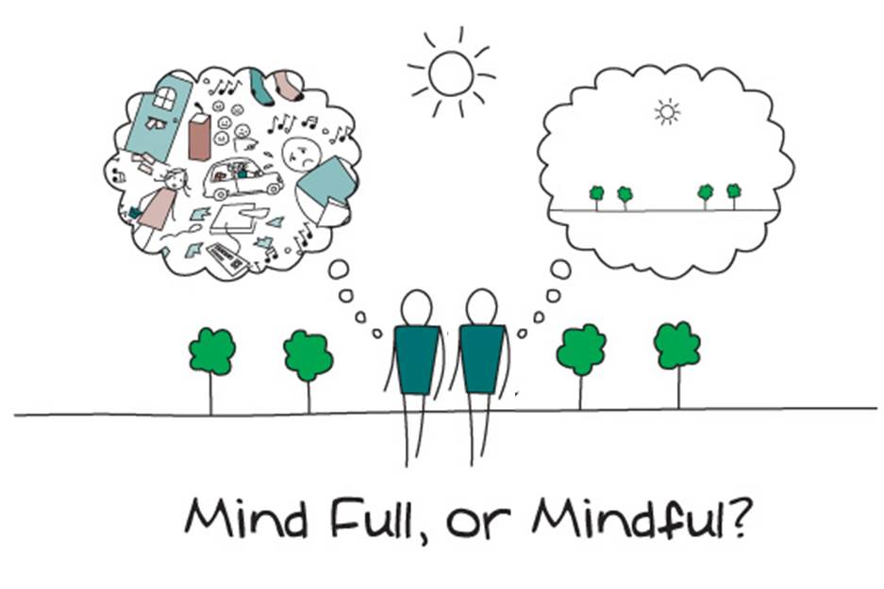

MBSR Class Guidelines:
Confidentiality –
Whatever is shared is to be held by the group alone.
Refraining from commenting to someone about what they shared in class.

Self-care –
Wear comfortable loose waisted clothing.
Wear layers in order to adjust to temperature changes in your designated classroom space.
Have a water bottle with you during class.
Bring whatever props or items that you would like for necessary support and/or comfort
*Take care to listen to your body and its needs – (changing positions, opting out of a practice that is too emotionally or physically challenging in any way, using the rest room….whatever may be needed!)

Attendance -
It is important to attend every class in order to achieve optimal benefit.
Each week builds on the prior week’s practices and themes.
Please call or notify Wendy if you will be missing a class for any reason.
You will have access to a Zoom recording for your review should you need to miss a class
If you will need to miss more than 2 classes it may be best to attend another session when you will be more available.

Home Practice –
Home practice is an integral part of the program.
This may take approximately 45 minutes to one hour each day.
This commitment to make time each day for practice will involve preparation logistically, socially and materially.
The willingness to meet oneself in the face of resistance, fatigue, boredom, restlessness, fear, pain, or whatever may arise - is extremely important!
*You will be provided with a recording and a home assignment sheet each week.
Feel free to contact Wendy with any questions, concerns or for any form of support that you may need between classes at 231-342-9634

Recordings for Home Practice –
All recordings for weekly practices can be found on the Northern Michigan Psychiatric Services website www.nmpspc.com/classes/ www.mindfulnesstc.com under the tab “CLASSES” where you will find “Free Adult Meditations.”
Although there will be a number of recordings, for the sake of better learning and flow try to stick with the assigned recording for the week.

Optional but Recommended Daily Self-Care –
60 minutes of Daily Physical Activity (30-45 minutes 3-7 days/week should be aerobic in nature)
Journal: What you are noticing as a result of your regular mindful practice/home assignments plus; 3 things you are grateful for, 1 kind word or words of encouragement, 1 intention for the day, and 3 ‘Wins’ of the day.
Look strangers in the eye, smile and say hello
Offer Random Acts of Kindness

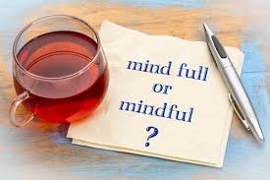
MBSR Class Schedule
Week 1
Saturday May 2nd
9:00-11:30
Arrive at least 5 minutes early to the Zoom Classroom each week in order to settle in to your space

Have all necessary items set up and ready to go in your space prior to each class.

Watch the Zoom Tutorial at www.mindfulnesstc.com to familiarize yourself with this online classroom format.

- Wear lose comfortable clothing

- Try out the link provided in the Zoom invitation prior to class and check for any technical issues.

- Bring a water bottle to class

- Feel free to bring your favorite cushion, mat, bolster or blanket

- Contact Wendy if you will be missing a class for any reason.

- Feel free to contact Wendy throughout the session for ANY and ALL concerns or questions.

231-342-9634
wendyweckstein@gmail.com

Website for Class Recordings

WWW.MINDFULNESSTC.COM
OR
nmpspc.com/classes/free-meditations/

Tips

Week 2
Saturday May 9th
9:00-11:30

Week 3
Saturday May 16th
9:00-11:30

Week 4
Saturday May 23rd
9:00-11:30

Week 5
Saturday May 30th
9:00-11:30

Week 6
Saturday June 6th
9:00-11:30

Saturday June 13th
Full Day Silent Retreat
8:30am-4:30pm

Week 7
Saturday, June 20th
9:00-11:30

Week 8
Saturday, June 27thth
9:00-11:30

Risks
Engagement in MBSR Program may be seen as a risk to one’s lifestyle given time and commitment. It may exacerbate or bring into one’s awareness – more strongly- physical, emotional, psychological or relational issues
- Physical
- Emotional
- Psychological
- Social
- Time

How to Support Getting the Most Out of This Course

- Strong commitment to daily practice
- Actively cultivating a stance of curiosity
- Attending all 8 weeks and full day retreat
- Fully engaging in class even if you do not wish to share
- Recognizing that while practice seems simple, bringing moment to moment awareness to our experiences formally and informally “is the hardest thing in the world to do” JKZ

Other Resources:
- Full Catastrophe Living by Jon Kabat Zinn
- Mindfulness by Joseph Goldstein
- Mindfulness for Beginners by Jon Kabat Zin

Home Assignment

Think about what brought you here…
Feel free to try out the Brief Sitting Meditation – 8- Minute

