Mindfulness-Based Stress Reduction - MBSR
Northern Michigan Psychiatric Services, PC
Wendy Weckstein - wendyweckstein@gmail.com - 231-342-9634
Recordings: www.nmpspc.com classes – free adult meditations

Week 1 Home Assignment
- Practice the Body Scan with the class recording at least 6 times this week

- Complete the 9-Dot Exercise; notice how you approach the assignment- what thoughts and emotions arise as you do?

- Eat one meal with full awareness. If this isn’t possible, take the first 3-5 bites of your meal mindfully.

- A few times each day, pause in your activity and bring awareness to the present moment; allow yourself to become fully present to what is actually happening… attending to what can be seen, heard, felt even smelled -bringing awareness to sensations in the body and the breath, thoughts and emotions. Rest in this space and stillness… and then return to the task at hand. Notice the effect this has as you proceed.

“As long as you are breathing, there is more right with you than there is wrong, no matter how ill, how hopeless you may feel, all challenges and difficulties are workable. Mindful awareness is fundamental to this understanding. Since the present moment is the only time anyone ever has for gaining information for perceiving, learning, growing and transforming!”

“Mindfulness is about being fully awake in our lives. It is about perceiving the exquisite vividness of each moment. With this we feel more alive. We also gain immediate access to our own powerful inner resources for insight, transformation and healing.”
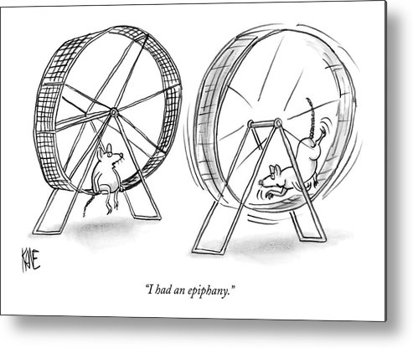
JKZ

Guidelines for doing the Body Scan:

- Do not listen to body scan recording while driving
- As you follow along with the body scan it is helpful to bring an attitude of warm, curious interest to whatever you are noticing in your experience. This is true whether you are sensing how a particular area of the body feels, a very active mind, boredom, sleepiness or anything else. There is no particular experience you are trying to have other than to be with and know something about what is actually happening.
- Remember it is not a problem if the mind wanders a lot, that your concentration isn’t strong, or that no matter what you do, thoughts keep returning to some particular event. None of this is a problem. The only thing to do is to recognize that this is occurring and then gently and kindly return the attention to wherever you are in the body scan.
- Keep in mind that trying to fight off unpleasant sensations, emotions, or thoughts often results in more tension. Instead you might try to cultivate a sense of allowing things to be as they are. You could try softening around the unpleasant experience and see what happens. This doesn’t mean you need to overwhelm yourself. If you choose to check in with the unpleasant experience, take it easy… there’s nowhere to go, nothing to “get”, you’re just experimenting and seeing what can be felt and known.
- Notice if you have thoughts about success, failure, perfection or getting somewhere. These thoughts are normal - and they can also get in the way of learning. The body scan is not a skill you are striving to perfect.
- Notice if there are expectations about what the body scan will do for you. If so, just allow it to be a seed that you are planting. With regular practice of the body scan the seed will grow to become a life lived with more awareness and freedom to choose appropriate responses. Cultivate this with regular and frequent practice and time to devote to yourself with privacy and quiet.
- The biggest guideline is to JUST PRACTICE! You do not need to feel a particular way during or after the body scan, nor do you have to “like” the body scan…simply practice. Acknowledge your commitment and intention for learning about mindfulness and trust the emergence from the practice over time.

