Mindfulness-Based Stress Reduction - MBSR
Northern Michigan Psychiatric Services, PC
Wendy Weckstein PT, MEd - wendyweckstein@gmail.com - 231-342-9634
Recordings: www.mindfulnesstc.com “Free Adult Meditations”

Week 3 Home Practice Assignment

- Alternate practicing the Body Scan with the Lying Down Yoga Sequence every other day using the recordings, at least 6 days this week

- Practice Sitting Meditation - Focused Attention Meditation - for 15-20 minutes each day with no recording

- Complete the Unpleasant Event Calendar – one entry for each day

- Become aware of ordinary moments during the day, capturing with awareness what is happening in the body, the mind, and with your emotions. Bring awareness to autopilot moments. Once you bring attention to them, do they stay automatic? What shifts? Are there perhaps particular experiences or circumstances where being on autopilot occurs more frequently? No need to change anything, just bring curiosity to it all.

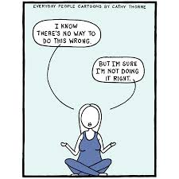
- Life is right now - Jon Kabat-Zinn You Tube
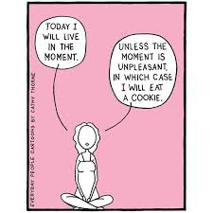

 | What was the experience? | Were you aware of unpleasant feelings while the event was happening? | How did your body feel, in detail, during this experience? | What moods, feelings and thoughts accompanied this event? | What thoughts are in your mind now as you write about this event?
Monday
Tuesday

Wednesday

Thursday

Friday

Saturday

Sunday

Unpleasant Events Calendar *use the back of this sheet to add more details

There is a Hole in My Sidewalk
by Portia Nelson

Chapter I
I walk down the street.
There is a deep hole in the sidewalk
I fall in.
I am lost … I am helpless.
It isn’t my fault.
It takes forever to find a way out.

Chapter II
I walk down the same street.
There is aThe breezes at dawn have secrets to tell you deep hole in the sidewalk.
I pretend I don’t see it.
I fall in again.
I can’t believe I am in the same place.
But, it isn’t my fault.
It still takes a long time to get out.

Chapter III
I walk down the same street.
There is a deep hole in the sidewalk.
I see it is there.
I still fall in … it’s a habit … but,
my eyes are open.
I know where I am.
It is my fault.
I get out immediately.

Chapter IV
I walk down the same street.
There is a deep hole in the sidewalk.
I walk around it.

Chapter V
I walk down another street.

Don’t Go Back to Sleep
by Rumi
The breezes at dawn have secrets to tell you.
Don’t go back to sleep.
You must ask for what you really want.
Don’t go back to sleep.
People are going back and forth across the doorsill
where the two worlds touch.
The door is round and open.
Don’t go back to sleep.

Walking Slowly
by Dana Faulds
It only takes a reminder to breath,
a moment to be still, and just like that,
something in me settles, softens, makes
space for imperfections.

The harsh voice of judgment drops to a whisper
and I remember again that life isn’t a relay race;
that we will all cross the finish line;
that waking up to life is what we were born for.

As many times as I forget,
catch myself charging forward
without even knowing where I am going,
that many times I can make the choice
to stop, to breathe, and be,
and walk slowly into the mystery.

