Mindfulness-Based Stress Reduction - MBSR
Northern Michigan Psychiatric Services, PC
Wendy Weckstein - wendyweckstein@gmail.com - 231-342-9634

Week 3 Home Practice Assignment

- Alternate practicing the Body Scan with the Lying Down Yoga Sequence every other day using the recordings, at least 6 days this week

- Practice Sitting Meditation - Focused Attention Meditation - for 15-20 minutes each day with no recording

- Complete the Unpleasant Event Calendar – one entry for each day

- Become aware of ordinary moments during the day, capturing with awareness what is happening in the body, the mind, and with your emotions. Bring awareness to autopilot moments. Once you bring attention to them, do they stay automatic? What shifts? Are there perhaps particular experiences or circumstances where being on autopilot occurs more frequently? No need to change anything, just bring curiosity to it all.

- Life is right now - Jon Kabat-Zinn You Tube

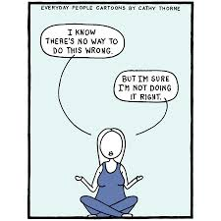

There is a Hole in My Sidewalk
by Portia Nelson
Chapter I
I walk down the street.
There is a deep hole in the sidewalk
I fall in.
I am lost … I am helpless.
It isn’t my fault.
It takes forever to find a way out.
Chapter II
I walk down the same street.
There is a deep hole in the sidewalk.
I pretend I don’t see it.
I fall in again.
I can’t believe I am in the same place.
But, it isn’t my fault.
It still takes a long time to get out.
Chapter III
I walk down the same street.
There is a deep hole in the sidewalk.
I see it is there.
I still fall in … it’s a habit … but,
my eyes are open.
I know where I am.
It is my fault.
I get out immediately.
Chapter IV
I walk down the same street.
There is a deep hole in the sidewalk.
I walk around it.
Chapter V
I walk down another street.

