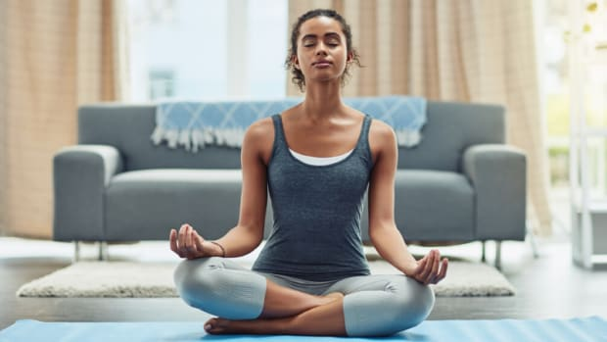
Mindful Movement/Yoga and
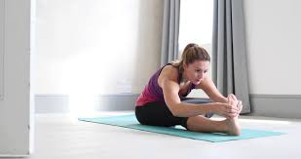
Meditation for Adults
Spring/Summer 2020

Beginning Fridays, April 3rd
7:00 am – 7:45 am

FREE Weekly Classes via ZOOM
______________________________________________

Mindful Movement and Meditation for Adults is an ongoing free class designed for adults who would like to deepen their mindfulness practice through weekly guided meditations and mindful movement (yoga.) This ongoing virtual class is available for all those who have participated in a Mindfulness-Based Stress Reduction (MBSR) class, or have some prior experience with yoga and meditation.

__ _______________________________________________

Spring/Summer 2020
April 3rd - Ongoing Fridays 7:00am – 7:45am

Program Cost:
NO COST
Must have participated in MBSR or have some experience with yoga and meditation

Class Location:
Zoom Online Classroom
Participants in the Mindful Movement and Meditation Class
will be involved in:
- 15 minutes of guided meditation (with an option to stay for an additional 15 minutes of silent meditation)
- 30 minutes of mindful movement or yoga

Mindfulness strengthens our ability to pay attention to the
present moment; to notice our thoughts, feelings and physical sensations
with curiosity and without judgment. When inspiring awareness through mindfulness - instead of reacting Mindlessly, we respond Mindfully.

To Register:
Contact Northern Michigan Psychiatric Services, PC at:
231-935-0355
or register online at www.mindfulnesstc.com

About the Instructor
Wendy Weckstein, PT, MEd, is a Physical Therapist, Wellness Consultant. and Mindfulness Based Stress Reduction - MBSR Teacher through Brown University’s School of Public Health. In addition she is certified in Mindfulness Based Stress Reduction for Teens (MBSR-T). Wendy provides health and wellness evaluations, customized fitness and wellness programming, and healthy living and mindfulness classes for pre-teens, teens and young adults at Northern Michigan Psychiatric Services, PC

