Wendy Weckstein, PT, MEd Northern Michigan Psychiatric Services, PC
www.nmpspc.com/classes or www.mindfulnesstc.com
wendyweckstein@gmail.com
(C) 231-342-9634
(O) 231-935-0355
MBSR Orientation

What is Mindfulness Based Stress Reduction MBSR?
MBSR is an eight-week, evidence-based, psychoeducational program offering secular, intensive mindfulness training; assisting people with a host of stress-related physical, emotional and psychological conditions. MBSR provides a practical approach to gaining a deeper level of awareness, and becoming more fully (and actively) engaged in all areas of one’s life. It is group-based and highly experiential, using a combination of mindfulness meditation, body awareness practices, yoga, and the exploration of habitual patterns of behavior, thinking, feeling and action.
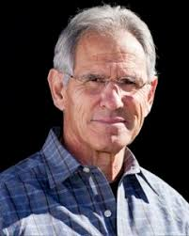
MBSR was developed at the University of Massachusetts Medical Center in the 1979 by Dr. Jon Kabat-Zinn.
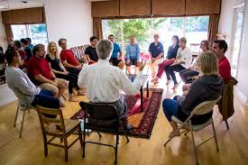

The 8- week class, along with regular and ongoing home practice, systematically trains attention - cultivating present moment (or moment-to-moment) awareness. With this greater level of awareness, it then becomes possible to discover and utilize one’s own inner resources for enhancing emotional regulation, stress management, level of contentment and overall enthusiasm for life. Integrating mindfulness strategies and practices into one’s life has the potential to deeply transform one’s relationship towards their stress. MBSR offers self-efficacy and essential coping skills for becoming resilient in both body and mind.

It is important to realize that MBSR is not a panacea. Although mindfulness is a powerful tool with the potential to provide us with many benefits, it is a compliment, not a replacement to modern medicine. There are no guarantees or predications as to a particular outcome – each person responds differently – however in general those who practice regularly and consistently, report more positive outcomes!
Research

- University of Massachusetts www.umassmed.edu/mbsr-journalarticles -
- Brown University www.brown.edu/public-health/mindfulness/research -
- University of Wisconsin – Richard Davidson www.centerforhealthyminds.org/about/founder-richard-davidson -
- Mindful Awareness Research Center – UCLA https://www.semel.ucla.edu/marc

Science
- Positive Neuroplasticity – the ability of the brain to change and grow - building new and stronger neuronal pathways based on repetitive behavior. (both positive and negative)

- Brain Growth – functional imaging reveals increase brain growth in regions of the brain associated with empathy, compassion, perspective taking, emotional regulation - mood, memory, planning and attention…to name a few - and a down- regulation and size of the ‘alarm center’ (amygdala)

Potential Benefits MBSR

- Improved emotional regulation and emotional balance
- Enhanced ability to cope with - and ameliorate the secondary complications and effects of chronic illness and stress
- Enhanced resiliency
- Improved sense of well-being
- Improved self-esteem
- Increased ability to meet high stress situations and to care for oneself in the midst of high stress demands
- Increased appreciation for, and ability to utilize, one’s inner resources and capabilities
- Increased attention, focus and memory – decreased distractibility
- Increased ability for broader perspective taking, compassion and empathy
- Increased joy and contentment - quality of life
- Improved sense of self-efficacy and self-control
- Prevents, reverse or reduces symptoms of numerous disease processes
  - Anxiety
  - Depression
  - PTSD
  - Chronic Pain
  - Fibromyalgia
  - Skin Disorders
  - Sleep Disorders
  - Hypertension
  - Heart Disease
  - Asthma
  - Cancers
  - Eating Disorders

What is Mindfulness?
“The awareness that arises from paying attention in a particular way to the present moment, on purpose and without judgment.” JKZ
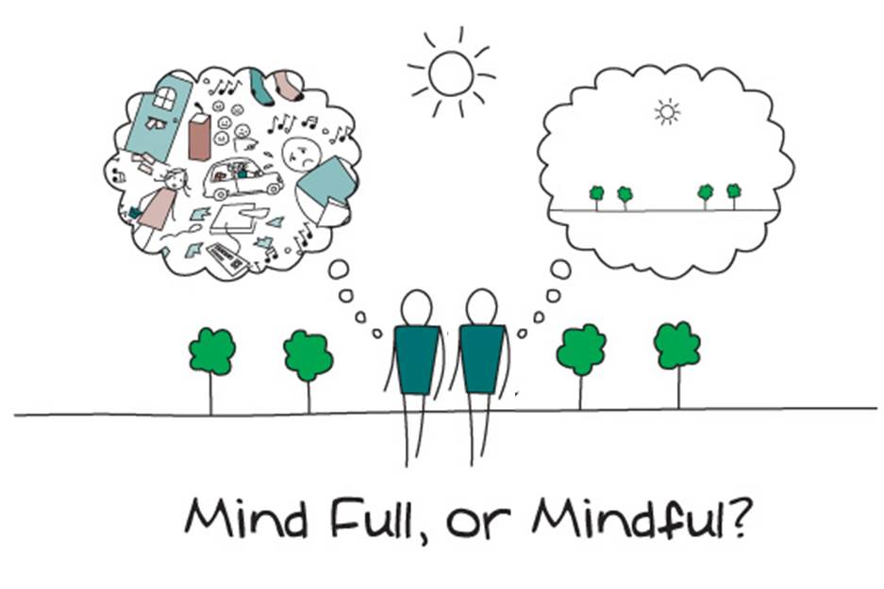

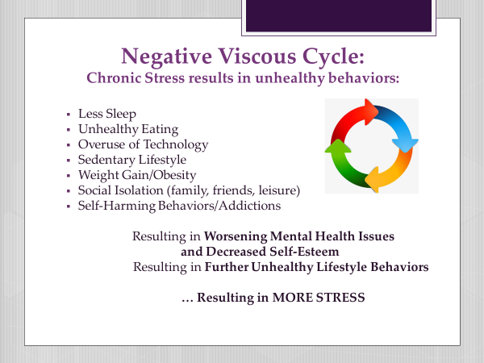

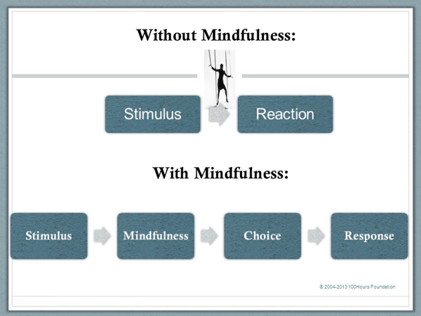

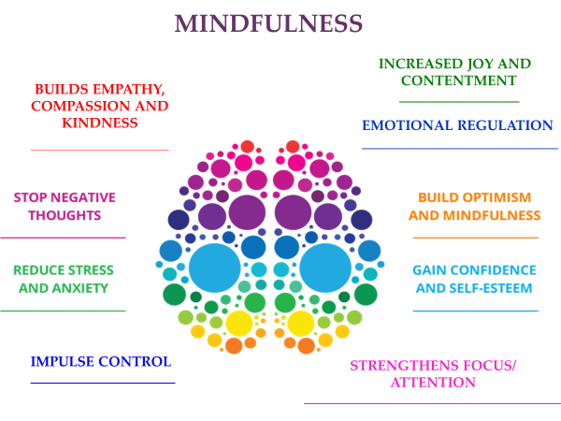

MBSR Class Guidelines:

Confidentiality
- Whatever is shared is to be held by the group alone.
Refraining from commenting to someone about what they shared in class.

Self-care
- Wear comfortable loose waisted clothing.
- Wear layers in order to adjust to temperature changes in your designated classroom space.
- Have a water bottle with you during class.
- Bring whatever props or items that you would like for necessary support and/or comfort
- *Take care to listen to your body and its needs – (changing positions, opting out of a practice that is too emotionally or physically challenging in any way, using the rest room….whatever may be needed!)

Attendance
- It is important to attend every class in order to achieve optimal benefit.
- Each week builds on the prior week’s practices and themes.
- Please call or notify Wendy if you will be missing a class for any reason.
- You will have access to a Zoom recording for your review should you need to miss a class
- If you will need to miss more than 2 classes it may be best to attend another session when you will be more available.

Home Practice
- Home practice is an integral part of the program.
- This may take approximately 45 minutes to one hour each day.
- This commitment to make time each day for practice will involve preparation logistically, socially and materially.
- The willingness to meet oneself in the face of resistance, fatigue, boredom, restlessness, fear, pain, or whatever may arise - is extremely important!
- *You will be provided with a recording and a home assignment sheet each week.

Recordings for Home Practice
- All recordings for weekly practices can be found on the Northern Michigan Psychiatric Services website www.mindfulnesstc.com where you will find “Free Adult Meditations.”
- Although there will be a number of recordings, for the sake of better learning and flow try to stick with the assigned recording for the week.

Class Documents for Home Practice
- Weekly Home Practices can be found at www.mindfulnesstc.com on the class page for “MBSR Mindfulness Based Stress Reduction for Adults.” On the right side of this page you will find Class Documents. Here you will be able to download and/or print the assignments for the week.

Optional but Recommended Daily Self-Care
- 60 minutes of Daily Physical Activity (30-45 minutes 3-7 days/week should be aerobic in nature
- Get outside and enjoy nature
- Get enough sleep
- Be thoughtful of time spent on technology
- Eat a healthy diet
- Journal: What you are noticing as a result of your regular mindful practice/home assignments
- 3 things you are grateful for
- 1 kind word or words of encouragement
- 1 intention for the day
- 3 ‘Wins’ of the day.
- Look strangers in the eye, smile and say “hello”
- Offer Random Acts of Kindness

Arrive at least 5 minutes early to the Zoom Classroom each week in order to settle in to your space

Have all necessary items set up and ready to go in your space prior to each class.

Have a journal for in-between class reflection – note taking is not necessary

Establish a space for each class and for your daily practice that is quiet and where you will least likely be disturbed. Consider using headphones for noise control

Watch the Zoom Tutorial at www.mindfulnesstc.com to familiarize yourself with this online classroom format.

Wear loose comfortable clothing

Bring a water bottle to class

Feel free to bring your favorite cushion, mat, bolster or blanket

Contact Wendy if you will be missing a class for any reason.

Feel free to contact Wendy throughout the session for ANY and ALL concerns or questions.

231-342-9634
wendyweckstein@gmail.com

Tips

Risks
Engagement in MBSR Program may be seen as a risk to one’s lifestyle given time and commitment. It may exacerbate or bring into one’s awareness – more strongly- physical, emotional, psychological or relational issues
- Physical
- Emotional
- Psychological
- Social
- Time

How to Support Getting the Most Out of This Course

- Strong commitment to daily practice
- Actively cultivating a stance of curiosity
- Realizing that there is no right or wrong way to do this or experience this practice
- Attending all 8 weeks and full day retreat
- Fully engaging in class even if you do not wish to share
- Recognizing that while practice seems simple, bringing moment to moment awareness to our experiences formally and informally “is the hardest thing in the world to do” JKZ

Other Resources:
- Full Catastrophe Living by Jon Kabat Zinn
- Mindfulness by Joseph Goldstein
- Mindfulness for Beginners by Jon Kabat Zin

Home Assignment

- Think about what brought you here…

Arrive at least 5 minutes early to the Zoom Classroom each week in order to settle in to your space

Have all necessary items set up and ready to go in your space prior to each class.

Establish a space for each class and for your daily practice that is quiet and where you will least likely be disturbed. Consider using headphones for noise control

Watch the Zoom Tutorial at www.mindfulnesstc.com to familiarize yourself with this online classroom format.

Wear loose comfortable clothing

Bring a water bottle to class

Feel free to bring your favorite cushion, mat, bolster or blanket

Contact Wendy if you will be missing a class for any reason.

Feel free to contact Wendy throughout the session for ANY and ALL concerns or questions.

231-342-9634
wendyweckstein@gmail.com

Tips

Risks
Engagement in MBSR Program may be seen as a risk to one’s lifestyle given time and commitment. It may exacerbate or bring into one’s awareness – more strongly- physical, emotional, psychological or relational issues
- Physical
- Emotional
- Psychological
- Social
- Time

How to Support Getting the Most Out of This Course

- Strong commitment to daily practice
- Actively cultivating a stance of curiosity
- Attending all 8 weeks and full day retreat
- Fully engaging in class even if you do not wish to share
- Recognizing that while practice seems simple, bringing moment to moment awareness to our experiences formally and informally “is the hardest thing in the world to do” JKZ

Other Resources:
- Full Catastrophe Living by Jon Kabat Zinn
- Mindfulness by Joseph Goldstein
- Mindfulness for Beginners by Jon Kabat Zin

Home Assignment

- Think about what brought you here…

Mindfulness Based Stress Reduction-MBSR Private Class for MMHPI

*Online Via Zoom

MBSR I Tuesdays May 12th – June 30th 11:00 am – 1:00 pm CST

MBSR II Thursdays May 14th – July 2nd 8:30 am – 10:30 pm CST
____________________________________________________
What is MBSR? Mindfulness-Based Stress Reduction (MBSR) is a highly experiential, evidence-based 8-week class and full day Mindfulness Retreat. This psycho-educational program helps participants cultivate a different relationship with stress resulting from chronic physical and/or psychological illnesses; helping one to better navigate through life’s inevitable challenges. Each session of MBSR incorporates a significant component of mindfulness practice, which forms the centerpiece of the MBSR program, including mindfulness meditation, mindful movement and other meditative practices. In addition, each session integrates group dialogue, sharing and some didactic presentation. Jon Kabat-Zinn founded MBSR at the University of Massachusetts in 1979. It is now taught in hundreds of settings worldwide. Research on MBSR has demonstrated positive outcomes and profound benefits with both physical and psychological symptoms including: depression, anxiety, overall mood, level of optimism, pain management and decreased risk and reversal of numerous disease processes.
“Mindfulness is the awareness that arises from paying attention to the present moment in a particular way, on purpose and without judgement.”
Jon Kabat-Zinn
Orientation Tuesday, April 28th 12:00 pm – 1:00 pm CST

Full Day Retreat – virtual Saturday, June 13th 7:45 am – 3:30 pm CST

TO REGISTER www.mindfulnesstc.com
Choose Class titled:

MMHPI (private) MBSR Mindfulness Based Stress Reduction for Adults

