Mindfulness-Based Stress Reduction - MBSR
Northern Michigan Psychiatric Services, PC
Wendy Weckstein PT, MEd - wendyweckstein@gmail.com - 231-342-9634
Recordings: www.mindfulnesstc.com “ Free Adult Meditations”

Week 4 Home Practice Assignment

- Alternate practicing the Body Scan with the Lying Down Yoga Sequence every other day using the recordings, at least 6 days this week

- Sitting Meditation - 15-20 minutes each day with attention starting with the chosen anchor, moving awareness to the whole body – and then the possibility of investigating sensations (including thoughts and emotions) that are “unwanted.”

- Be aware of automatic habitual stress reactions and behaviors during the week – without trying to change them in any way.

- Be aware of times you may feel stuck, blocking, numbing, and shutting off to the moment when it happens this week. Do you recognize this as a pattern? * Approach these two assignments as if they are an experiment, a possibility to see and learn something new (as you might look at the 9-Dots)

- Review information about stress in handout provided

“Between stimulus and response there is a space. In that space is our power to choose our response. In our response lies our growth and our freedom.”

Victor E. Frankl – psychiatrist and holocaust survivor
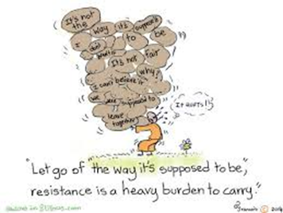

Paradox by Gunilla Norris
It is a paradox that we encounter so much internal noise
when we first try to sit in silence.
It is a paradox that experiencing pain, releases pain.
It is a paradox that keeping still can lead us so fully into life and being.

Our mind do not like paradoxes. We want things
to be clear, so we can maintain our illusions of safety.
Certainty breeds tremendous smugness.

We each possess a deeper level of being, however
which loves paradox. It knows that summer is already
Growing like a seed in the depth of winter.
It knows that the moment we are born we begin to die.
It knows that all of life shimmers, in shades of becoming-
that shadow and light are always together,
the visible mingled with the invisible.

When we sit in stillness, we are profoundly active.
Keeping silent, we hear the roar of existence.
Through our willingness to be the one we are,
We become one with everything.

A Breath of Life by Dana Faulds
I breath in ALL that is -
Awareness expanding
to take everything in,
as if my heart beats
the world into being.

From the unnamed vastness beneath the mind
I breath my way into wholeness and healing
Inhalation, Exhalation.
Each breath a YES
And a letting go, a journey and a coming home.

