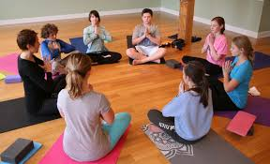

Yoga and Meditation Class for Teens
In-Person
Northern Michigan Psychiatric Services, PC and The Mindfulness Center of Northern Michigan, LLC Heritage Square Location - 934 S. Garfield A 231-935-0355
Mondays, 4:00 pm - 5:00 pm
October 4th - November 22nd
$165/8-week class

Register Now Class size is limited! www.mindfulnesstc.com
*Vaccinations are required to attend this class.

