A FREE Online Orientation to

Mindfulness Based

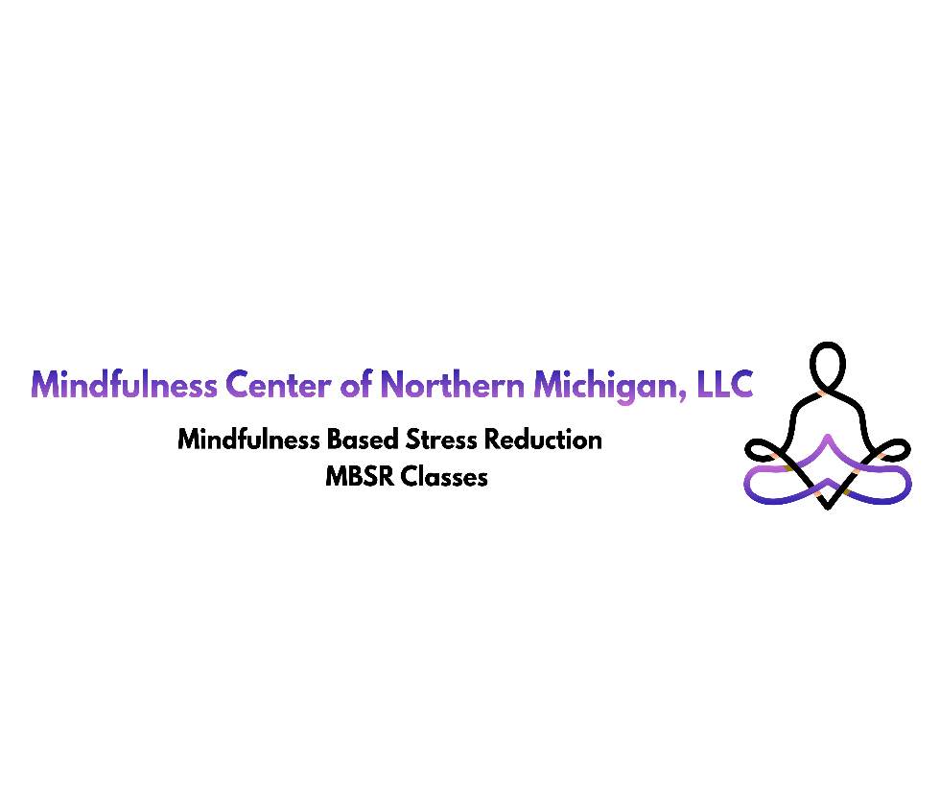
Stress Reduction - MBSR
Register at
www.mindfulnesstc.com to receive your Zoom Invitation or call 231-342-9634

Thursday, April 6th 2023 6:00pm – 7:00pm

Sponsored by:

Northern Michigan Psychiatric Services, PC

